**CHAPTER 1**

**INTRODUCTION**

Smart Learn Hub is a cutting-edge Java application designed to transform the educational experience by integrating advanced technologies with modern pedagogical techniques. In today's fast-paced and technology-driven world, the need for dynamic, flexible, and personalized learning platforms has become more critical than ever. Traditional education systems often struggle to meet the diverse needs of students and educators, resulting in a gap that hinders effective learning and teaching. Smart Learn Hub addresses these challenges by offering a comprehensive platform that adapts to individual learning styles and enhances the overall educational experience.

The application leverages the versatility and reliability of Java to provide a robust, scalable, and platform-independent system. By focusing on key aspects such as adaptive learning, interactive content, and real-time feedback, Smart Learn Hub ensures that learners can achieve their academic goals while fostering a culture of lifelong learning. The platform is designed to cater to a wide range of users, from school students and university learners to professionals seeking skill development.

One of the distinguishing features of Smart Learn Hub is its ability to analyze user behavior and provide personalized recommendations. This is achieved through the integration of intelligent algorithms that assess user performance, identify strengths and weaknesses, and suggest tailored learning paths. Additionally, the application incorporates gamification techniques to boost engagement and motivation, making learning both effective and enjoyable.

Smart Learn Hub also serves as a powerful tool for educators, offering an array of features to simplify course management, track student progress, and enhance communication. By fostering collaboration through group activities and discussion forums, the application promotes critical thinking, creativity, and teamwork among learners. With a strong emphasis on security and data privacy, Smart Learn Hub ensures that all users can engage with the platform confidently and securely.

**CHAPTER 2**

**EXISTING SYSTEM**

The current educational systems, both traditional and technology-based, face significant challenges in addressing the diverse needs of learners and educators. Traditional classrooms often rely on one-size-fits-all teaching approaches, which may not adequately cater to individual learning paces, styles, and preferences. This results in a lack of engagement and limited opportunities for personalized learning. Additionally, conventional methods of assessing student performance are often static and do not provide actionable insights for improvement.

In the realm of technology-based education, many existing systems suffer from fragmentation and limited adaptability. While some platforms offer online courses, others provide tools for assessments, content delivery, or communication. However, few systems offer an integrated solution that seamlessly combines these elements. Furthermore, most current platforms lack intelligent features that can analyze user behavior, adapt to individual needs, and provide personalized learning experiences.

Another critical limitation of existing systems is their inability to engage users effectively. Many online learning platforms rely heavily on passive content, such as pre-recorded lectures or static text, which fails to capture the interest of learners. The lack of interactive elements, gamification, or collaborative tools further diminishes user engagement and satisfaction.

For educators, the challenges are equally pronounced. Existing systems often provide limited tools for managing classrooms, tracking student performance, or designing customized learning paths. Communication tools are often inadequate, making it difficult for teachers to provide timely feedback or facilitate meaningful interactions with students.

Issues related to security, scalability, and user experience persist in many existing systems. Data privacy concerns and inconsistent performance across different devices and platforms hinder their widespread adoption. As a result, both learners and educators face significant barriers in leveraging technology to its full potential in education.

* 1. **Existing System Disadvantages**
* **Lack of Personalization**

Most existing educational systems fail to adapt to the individual needs of learners. Traditional teaching methods follow a uniform approach, which does not account for varying learning styles, paces, or preferences. Similarly, many technology-driven platforms lack intelligent algorithms to tailor content and assessments, leaving learners without the personalized guidance needed for optimal progress.

* **Limited Interactivity and Engagement**

Many current platforms rely heavily on static content, such as pre-recorded lectures or text-based materials, which fail to engage learners effectively. The absence of interactive features like simulations, gamified elements, or real-time feedback reduces interest and motivation, leading to lower retention rates and suboptimal learning outcomes.

* **Fragmented Tools and Systems**

Existing solutions often provide a narrow range of functionalities, requiring users to rely on multiple platforms for different purposes such as content delivery, assessments, and communication. This fragmentation creates inefficiencies, disrupts the learning experience, and makes it harder for both learners and educators to manage their activities seamlessly.

* **Inadequate Support for Educators**

Educators often struggle with systems that do not provide comprehensive tools for classroom management, progress tracking, or personalized lesson planning. The lack of advanced analytics and easy-to-use dashboards makes it challenging to monitor student performance effectively or intervene when necessary.

* **Concerns with Scalability and Security**

Many existing educational platforms face issues with scalability and data security. These systems often fail to deliver consistent performance across various devices and user bases, particularly during peak usage times. Additionally, inadequate measures for data protection raise significant privacy concerns, deterring users from fully embracing these platforms.

**CHAPTER 3**

**PROPOSED SYSTEM**

The proposed system, Smart Learn Hub, is a Java-based application designed to overcome the limitations of existing educational platforms by delivering an integrated, adaptive, and engaging learning experience. It leverages advanced algorithms, modern educational principles, and Java’s robust framework to create a versatile platform for learners and educators. Smart Learn Hub focuses on personalization, interactivity, and scalability, ensuring it caters to diverse learning and teaching needs.

Smart Learn Hub addresses the lack of personalization in existing systems by incorporating intelligent analytics to tailor the learning experience to individual needs. The platform assesses user behavior, performance, and preferences to generate customized learning paths. This ensures that each learner progresses at their own pace, strengthening their understanding of concepts and addressing their unique challenges.

Interactivity and engagement are at the forefront of the proposed system. Smart Learn Hub includes multimedia content such as videos, quizzes, and simulations, making learning more dynamic and enjoyable. Gamification elements, including badges, rewards, and leaderboards, further motivate learners to achieve their goals. Additionally, collaborative tools such as group projects, discussion forums, and live sessions foster communication and teamwork, essential skills in today’s educational landscape.

For educators, the system provides a comprehensive dashboard to streamline classroom management, track student performance, and design personalized assignments. Advanced analytics and visualization tools help teachers identify learning gaps, enabling timely intervention. The platform also facilitates seamless communication between educators and students, ensuring meaningful interactions and effective guidance.

From a technical standpoint, Smart Learn Hub is built to ensure scalability and security. The Java-based architecture enables consistent performance across different devices and operating systems, while robust data protection mechanisms safeguard user information. These features make the platform reliable and trustworthy for users, promoting widespread adoption.

* 1. **Proposed System Advantages**
* **Personalized Learning Experience**

The Smart Learn Hub employs intelligent algorithms to analyze user behavior, learning preferences, and performance. By doing so, it creates tailored learning paths that help students focus on their strengths while addressing their weaknesses. This personalized approach enhances knowledge retention and allows learners to progress at their own pace.

* **Enhanced Interactivity and Engagement**

The platform incorporates interactive multimedia content, including videos, quizzes, and simulations, to make learning more dynamic and engaging. Additionally, gamification techniques such as badges, leaderboards, and rewards further motivate learners to stay committed to their educational goals, transforming learning into an enjoyable experience.

* **Integrated and Comprehensive Solution**

Smart Learn Hub offers a unified platform that combines learning management, content delivery, assessments, and communication tools. This integration eliminates the need for multiple systems, streamlining the user experience for both students and educators. By providing all essential features under one roof, it ensures efficiency and ease of use.

* **Powerful Tools for Educators**

For educators, the system provides advanced features such as real-time analytics, student performance tracking, and customizable lesson plans. The educator dashboard offers a clear overview of individual and class progress, enabling timely interventions and personalized feedback. These tools simplify classroom management and improve teaching effectiveness.

* **Scalability and Accessibility**

Built using Java, Smart Learn Hub is designed to be platform-independent and highly scalable. It delivers consistent performance across various devices and operating systems, ensuring accessibility for users in diverse settings. This scalability makes it suitable for institutions of all sizes, from small schools to large universities.

**CHAPTER 4**

**SYSTEM REQUIREMENTS**

**4.1 HARDWARE REQUIREMENTS:**

* PROCESSOR : I3.
* Hard Disk : 40 GB.
* Ram : 2 GB.

**4.2 SOFTWARE REQUIREMENTS:**

* Operating system : Windows.
* Coding Language : JAVA/J2EE
* Data Base : MYSQL
* IDE : Netbeans8.1

**CHAPTER 5**

**SYSTEM ANALYSIS**

**1. System Overview**

**Smart Learn Hub:** A Java-based application designed to provide an interactive and personalized e-learning platform. It supports learners and instructors with features like course management, assessments, progress tracking, and real-time interactions.

**2. Objectives**

* Deliver a user-friendly platform for online learning.
* Provide tools for content creation, management, and distribution.
* Ensure scalability to handle a growing number of users.
* Enable real-time communication (e.g., chat or live classes).
* Offer progress tracking and analytics for learners and educators.

**3. Stakeholders**

* **Primary Users:**
* **Students:** To access courses, take quizzes, and track progress.
* **Educators:** To create and manage courses, assignments, and assessments.
* **Secondary Users:**
* **Administrators:** To manage users, handle content approvals, and oversee platform operations.

**4. Functional Requirements**

* **User Management:**
* Login/registration system.
* Role-based access control (student, educator, admin).
* Profile management.
* **Course Management**:
* Create, update, and delete courses.
* Upload and manage multimedia content.
* Organize courses into modules or topics.
* **Assessment and Quizzes:**
* Create customizable quizzes and assignments.
* Auto-grading and manual grading options.
* Feedback and score report for students.
* **Progress Tracking:**
* Track student activity and performance.
* Analytics dashboard for educators.
* **Communication Tools:**
* Integrated chat systems.
* Scheduling and hosting live classes or webinars.
* **Notifications:**
* Email or in-app notifications for deadlines, updates, or new content.

**5. Non-Functional Requirements**

* **Performance:**
* Support at least 1000 concurrent users.
* Ensure a response time of under 2 seconds for user actions.
* **Scalability:**
* Enable vertical and horizontal scaling as the user base grows.
* **Security:**
* Implement secure login (e.g., OAuth, password encryption).
* Protect sensitive user data with robust encryption.
* **Compatibility:**
* Support multiple platforms (desktop, mobile, web browsers).
* **Reliability:**
* Achieve 99.9% uptime.
* Handle unexpected failures with auto-recovery mechanisms.

**6. System Architecture**

* **Frontend:**
* JavaFX or React (for desktop/web applications).
* Responsive design for mobile compatibility.
* **Backend:**
* Java Spring Boot for application logic and API services.
* **Database:**
* MySQL/PostgreSQL for structured data.
* MongoDB for unstructured data like logs or analytics.
* **APIs:**
* RESTful APIs for seamless frontend-backend communication.
* **Cloud Services:**
* AWS or Azure for hosting, scalability, and storage.

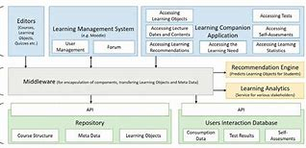

Fig 1: System Architecture

**7. Use Cases**

**Use Case 1:** User Registration/Login

* Actors: Student, Educator, Admin.
* **Steps:**

1. User enters credentials.
2. System validates and grants access.

**Use Case 2**: Course Creation

* Actors: Educator.
* **Steps:**

1. Educator inputs course details.
2. System stores course in the database.

**Use Case 3:** Progress Tracking

* Actors: Student, Educator.
* **Steps:**

1. Student accesses dashboard.
2. System retrieves and displays progress data.

**8. Potential Challenges**

* Handling real-time communication for live classes.
* Ensuring high availability under heavy load.
* Protecting sensitive data (e.g., quiz results, personal information).

**9. Tools and Technologies**

* **Frontend:** JavaFX, React, or Angular.
* **Backend:** Java with Spring Boot framework.
* **Database:** MySQL/PostgreSQL, MongoDB.
* **Other:**
* Firebase for real-time notifications.
* WebRTC for live video/audio communication.

**10. Deliverables**

* Requirements documentation.
* Use case diagrams and flowcharts.
* Prototype for key features.
* Fully functional system with testing reports.

**CHAPTER 6**

**UML DIAGRAMS**

**6.1 CLASS DIAGRAM:**

The class diagram is used to refine the use case diagram and define a detailed design of the system. The class diagram classifies the actors defined in the use case diagram into a set of interrelated classes. The relationship or association between the classes can be either an "is-a" or "has-a" relationship. Each class in the class diagram may be capable of providing certain functionalities. These functionalities provided by the class are termed "methods" of the class. Apart from this, each class may have certain "attributes" that uniquely.



Fig 2:class diagram

**6.2 USE CASE DIAGRAM:**

A use case diagram in the Unified Modelling Language (UML) is a type of behavioral diagram defined by and created from a Use-case analysis. Its purpose is to present a graphical overview of the functionality provided by a system in terms of actors, their goals (represented as use cases), and any dependencies between those use cases. The main purpose of a use case diagram is to show what system functions are performed for which actor. Roles of the actors in the system can be depicted.



Fig 3: Use case diagram

**6.3 SEQUENCE DIAGRAM:**

A sequence diagram represents the interaction between different objects in the system. The important aspect of a sequence diagram is that it is time-ordered. This means that the exact sequence of the interactions between the objects is represented step by step. Different objects in the sequence diagram interact with each other by passing "messages".



Fig 4: sequence diagram

**6.4 COLLABORATIVE DIAGRAM:**

A collaboration diagram groups together the interactions between different objects. The interactions are listed as numbered interactions that help to trace the sequence of the interactions. The collaboration diagram helps to identify all the possible interactions that each object has with other objects.



Fig5: Collaborative diagram

**CHAPTER 7**

**SYSTEM IMPLEMENTATION**

1. **Data Preprocessing**: Prepare textual data by removing noise like special characters, punctuation, and stop words. Tokenize the text into sentences or paragraphs for easier sentiment analysis and summarization.
2. **Sentiment Analysis Model**: Use pre-trained sentiment analysis models, including deep learning or transformer-based architectures, to detect sentiment polarity (positive, negative, neutral) in text accurately.
3. **Summarization Model**: Implement a text summarization model that generates concise summaries while maintaining sentiment information. Explore both extractive and abstractive techniques, focusing on coherence, informativeness, and preserving sentiment.
4. **Integration & Evaluation**: Integrate sentiment analysis with summarization to prioritize sentences based on sentiment polarity, ensuring summaries capture the text's emotional context.
5. **Evaluation**: Evaluate the system's performance using ROUGE for summarization quality and accuracy metrics for sentiment analysis. Use benchmark datasets to ensure effectiveness and robustness.
6. **Optimization**: Optimize the system for efficiency and scalability by leveraging techniques such as parallel processing, caching, and model compression. Consider deploying the system on distributed computing frameworks or utilizing hardware accelerators (e.g., GPUs) to improve processing speed and resource utilization.
7. **User Interface**: Develop a user-friendly interface for interacting with the system, allowing users to input text and view the generated summaries along with sentiment analysis results. Design the interface to be intuitive, responsive, and accessible across different devices and platforms
8. **Deployment**: Deploy the implemented system in production environments, considering factors such as scalability, reliability, and security. Ensure proper monitoring and maintenance procedures are in place to address potential issues and ensure continuous performance optimization.
9. **Feedback Loop**: Establish a feedback loop to gather user feedback and monitor system performance over time. Use feedback to iteratively improve the system's accuracy, usability, and effectiveness based on user requirements and evolving needs.

**CHAPTER 8**

**SYSTEM STUDY**

**Feasibility Study**

The possibility of the task is dissected in this stage and strategic agreement is advanced with an extremely broad arrangement for the venture and a few quotes. During framework investigation the attainability investigation of the proposed framework is to be done. This is to guarantee that the proposed framework isn't a weight to the organization. For achievability examination, some comprehension of the significant necessities for the framework is fundamental.

Three key contemplations associated with the achievability examination are:

* Practical Achievability
* Specialized Achievability
* SOCIAL Achievability

**Practical Achievability**

This study is completed to check the monetary effect that the framework will have on the association. How much asset that the organization can fill the innovative work of the framework is restricted. The consumptions should be legitimate. Accordingly, the created framework also reasonably affordable and this was accomplished in light of the fact that the majority of the advances utilized are unreservedly accessible. Just the tweaked items must be bought.

**Specialized Achievability**

This study is done to check the specialized practicality, or at least, the specialized necessities of the framework. Any framework created should not have a popularity on the accessible specialized assets. This will prompt high requests on the accessible specialized assets. This will prompt high requests being put on the client. The created framework should have an unassuming prerequisite, as just negligible or invalid changes are expected for carrying out this framework.

**ODBC**

Microsoft Open Database Connectivity (ODBC) is a standard interface for application developers and database system providers. Before ODBC, developers had to use proprietary languages for each database connection. ODBC simplifies this process, making the choice of database system almost irrelevant from a coding perspective, allowing developers to focus on more critical tasks rather than adapting their programs to different database syntaxes.

**Overview of ODBC (Open Database Connectivity)**

ODBC is a standard interface for developers and database systems, allowing applications to interact with various databases without being tied to a specific database syntax. Before ODBC, developers had to write proprietary code for each database, making the process cumbersome and limiting flexibility. With ODBC, the database choice becomes coding-agnostic, enabling developers to focus on core application functionality.

**Managing ODBC Data Sources**

ODBC Manager, accessible through the Control Panel, maps data sources to specific databases. For instance, a data source named "Sales" might connect to a SQL Server database, while "Accounts Payable" could link to an Access database. These databases can reside anywhere on a LAN. The ODBC setup is facilitated by tools like ODBCINST.DLL and ODBCADM.EXE, which support both 16-bit and 32-bit environments, maintaining separate lists of data sources.

**Benefits of ODBC**

ODBC's primary advantage is its universality: developers can write a single set of function calls to interact with any database, such as Oracle or SQL Server, without altering source code. ODBC supports various data sources, including Excel spreadsheets and plain text files. It manages low-level driver interactions and network issues transparently, making it ideal for client/server architectures.

**Performance Considerations**

Critics argue that ODBC is slower than native database interfaces. However, Microsoft and others suggest that driver quality significantly impacts performance. Modern ODBC drivers have improved efficiency, and the trade-off for cleaner, faster-to-develop applications is often worthwhile. Moreover, advancements in computing power help mitigate performance concerns over time.

ODBC streamlines database interaction, enhances development efficiency, and supports a wide range of data sources, making it an essential tool for modern application development despite minor performance trade-offs.

## **Networking**

TCP/IP stack: The TCP/IP stack is shorter than the OSI one:

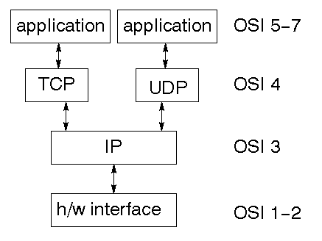

Fig 6: Networking TCP/IP stack

TCP is a connection-oriented protocol; UDP (User Datagram Protocol) is a connectionless protocol

**IP datagram’s**

The IP layer offers connectionless, unreliable delivery, handling each datagram independently. It includes a header with source/destination addresses and a checksum. It manages routing, fragments large datagrams for transmission, and reassembles them at the destination.

**UDP**

UDP is likewise connectionless and inconsistent. What it adds to IP is a checksum for the items in the datagram and port numbers. These are utilized to give a client/server model - see later.

**TCP**

TCP supplies rationale to give a dependable association situated convention above IP. It gives a virtual circuit that two cycles can use to convey.

**Web addresses**

To access a service on the web, its location must be identifiable. The internet uses a 32-bit IP address system to locate machines. This address encodes a network ID and specific addressing. Network IDs are categorized based on the size of the network address, enabling efficient identification and connectivity.

**Network address**

Class A purposes 8 pieces for the organization address with 24 pieces left over for other tending to. Class B utilizes 16-bit network tending to. Class C purposes 24-bit network tending to and class D purposes each of the 32.

**Subnet address**

Inside, the UNIX network is partitioned into sub organizations. Building 11 is as of now on one sub organization and utilizations 10-bit tending to, permitting 1024 unique hosts. The Haveaddress is8 pieces are at long last utilized for have addresses inside our subnet. This places a restriction of 256 machines that can be on the subnet.

**Total address**

The 32-bit address is usually written as 4 integers separated by dots.

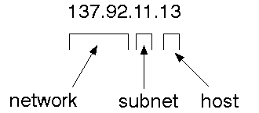

Fig 7: 4 Integers of 32-bit address

**Port Addresses**

A help exists on a host, and is recognized by its port. This is a 16-digit number. To make an impression on a server, you send it to the port for that help of the host that it is running on. This isn't area straightforwardness! Sure, of these ports are "notable"*.*

**Attachments**

An attachment is an information structure kept up with by the framework to deal with network associations. An attachment is made utilizing the call attachment. It returns a whole number that resembles a document descriptor. Truth be told, under Windows, this handle can be utilized with Read Document and Compose Record capabilities.

#incorporate <sys/types.h>

#incorporate <sys/socket.h>

int socket (int family, int type, int convention);

Here "family" will be AF_INET for IP interchanges, convention will be zero, and type will rely upon whether TCP or UDP is utilized. Two cycles wishing to convey over an organization make an attachment each. These are like two finishes of a line - however the genuine line doesn't yet exist.

### **CHAPTER 9**

### **SYSTEM TESTING**

The purpose of testing is to identify errors and weaknesses in a product. It involves evaluating components, subgroups, or finished products to ensure functionality meets requirements and user expectations. Various types of tests address specific testing needs, ensuring the software system operates correctly without failures.

**Sorts OF TESTS**

* **Unit testing**

Unit testing validates internal program logic, ensuring inputs produce correct outputs and all decision branches function properly. It tests individual software units after development but before integration, focusing on specific components and their behavior. Unit tests verify that each unique business process path meets specifications with defined inputs and expected results.

* **Reconciliation testing**

Integration tests ensure that combined software components function together as a single program. Focused on event-driven testing, it verifies that individual components, though tested independently, integrate correctly and consistently. The primary goal is to identify issues that arise from combining parts.

* **Utilitarian test**

Utilitarian tests give efficient showings that capabilities tried are accessible as indicated by the business and specialized necessities, framework documentation, and client manuals.

Useful testing is focused on the accompanying things:

* **Substantial Information:** distinguished classes of legitimate information should be acknowledged.
* **Invalid Information:** recognized classes of invalid info should be dismissed.
* **Capabilities:** distinguished capabilities should be worked out.
* **Yield:** recognized classes of utilization yields should be worked out.
* **Frameworks/Techniques:** interacting frameworks or methods should be conjured.

Functional testing focuses on requirements, key features, and specific scenarios. It ensures comprehensive coverage of business process flows, data fields, predefined processes, and hierarchical cycles. Before performing functional testing, additional tests are identified, and the practical value of existing tests is assessed.

* **Framework Test**

System testing ensures the integrated software system meets requirements. It focuses on process flows, configuration, and predictable outcomes. The goal is to test integration points and confirm system functionality.

* **White Box Testing**

White Box Testing is a trying where wherein the product analyzer knows about the inward functions, construction and language of the product, or possibly its motivation. It is reason. Used to test regions can't be reached from a black box level.

* **Discovery Testing**

Discovery testing is a black-box testing approach where the tester is unaware of the software's internal workings. It focuses on validating inputs and outputs based on specifications or requirements. The goal is to ensure the software meets expectations without examining its internal logic.

**Unit Testing**

Unit testing is typically performed during the integrated code and unit test phase of the software lifecycle, though coding and unit testing are often conducted as separate stages.

**Test technique and approach**

Field testing will be performed physically and practical tests will be written exhaustively.

**Test targets**

* All field sections should work appropriately.
* Pages should be enacted from the distinguished connection
* The passage screen, messages and reactions should not be postponed.

**Highlights to be tried**

* Check that the passages are of the right arrangement
* No copy sections ought to be permitted
* All connections ought to take the client to the right page

**Incorporation Testing**

Integration testing gradually combines software components to detect interface defects, ensuring that different parts or applications work together correctly without errors.

**Test Results:** All the experiments referenced above passed effectively. No imperfections experienced.

**Acknowledgment Testing**

Client Acknowledgment Testing is a basic period of any venture and requires critical support toward the end client. It additionally guarantees that the framework meets the utilitarian necessities.

**Test Results:** All the experiments referenced above passed effectively. No imperfections experienced.

### **CHAPTER 10**

**OUTPUT**

In this project we are developing Online based Education System where users can view and download require material and can request related materials from other users. Users can post their doubts or queries and the other users will reply for those queries.

Education is an important need for all humans and play major role in any countries development but existing education system require students to visit college or library campus to get require education and if they have any doubt then they need to consult their guide manually to clear their guide which is time consuming process.

In propose online application students can get education from his home just they need a computer with NET connection. In propose application student can ask query from any expert and can view and download require material and can request new materials also.

To implement this project, we have created following database.

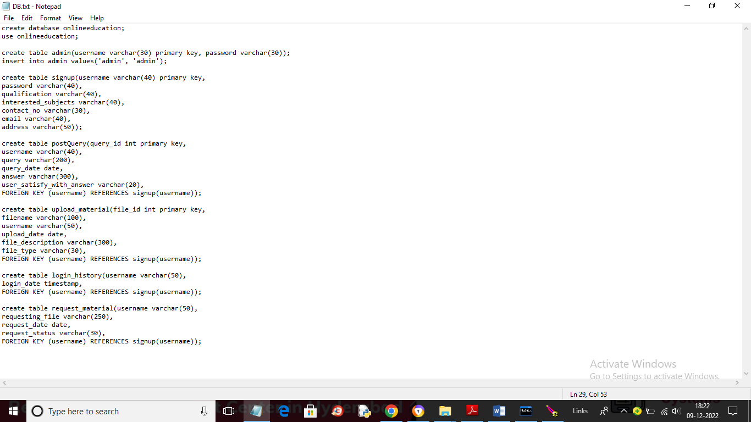

Fig 8: Database Creation: Tables and Key Relationships

In above Fig 8 ,you can see we created database and then created different tables with different attributes and each table has Primary and foreign key relation.

To implement this project, we have designed following modules:

1. **Admin Login:** Admin can login to system by using username and password as ‘admin’ and then can view list of registered users who are accessing this application
2. **User Signup**: using this module new user can sign up with the application
3. **User Login:** user can login to system
4. **Upload Material:** user can upload material which he has and other users can view and download those material for online study
5. **View Material:** user can view list of available tutorials and can download
6. **Request New Material:** user can request other user to post requested material and the user who has this material will upload that
7. **Post Query:** user can post his doubt also
8. **Answer Query:** Any user who know answer will reply for this query

**SCREEN SHOTS**

Create database in MYSQL by copying content from DB.txt file and paste in MYSQL console and then paste code folder inside tomcat WEBAPP directory and then start your tomcat server and then open browser and enter URL as [http://localhost:port_no/OnlineEducation](https://encoded-592c9deb-987b-4562-aa3c-9fa3d37d83e9.uri/http%3a%2f%2flocalhost%3aport_no%2fOnlineEducation) and press enter key to get below page

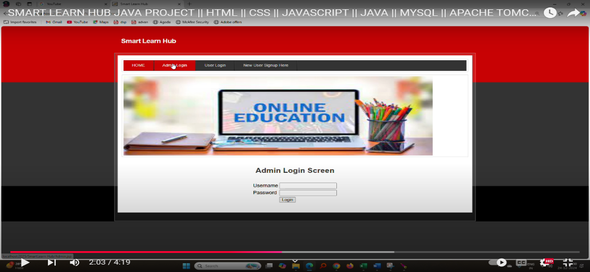

Fig 9: New User Signup: Link to Registration

In the above Fig: 9, click on the ‘New User Signup Here’ link to navigate to the screen shown below.

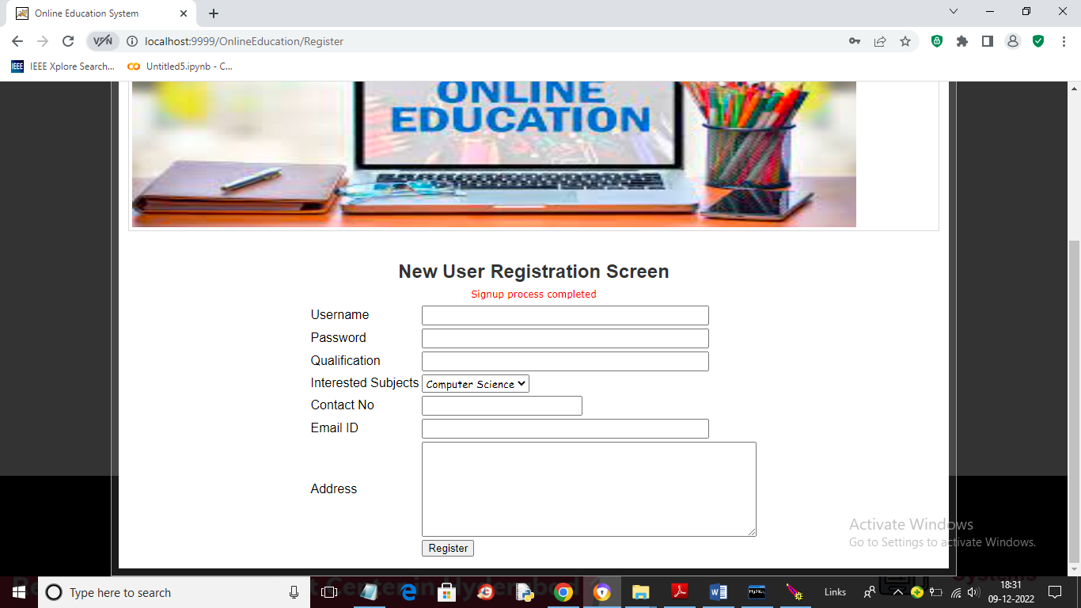

Fig 10: User Signup: Enter Details and Register

In the above Fig: 10, the user is signing up by entering the required details and then clicking on the ‘Register’ button to proceed to the screen shown below.

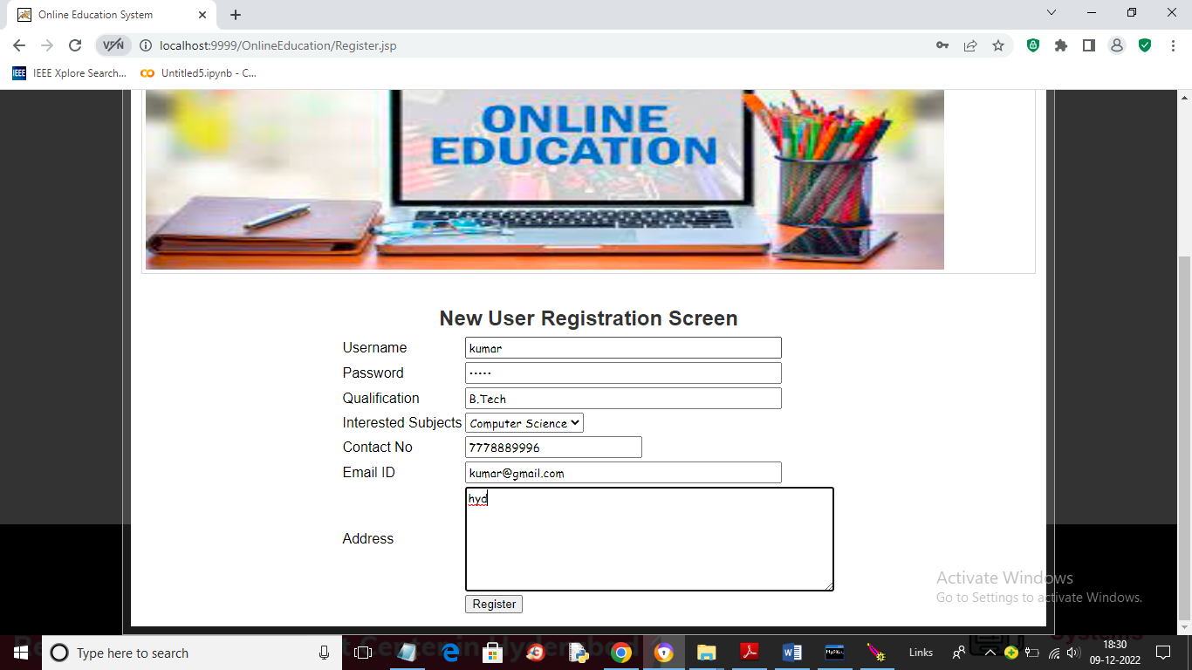

Fig 11: Signup Completed: Navigate to User Login

In above Fig: 11, the red text indicates that the signup task has been completed. Now, click on the ‘User Login’ link to proceed to the login screen shown below.

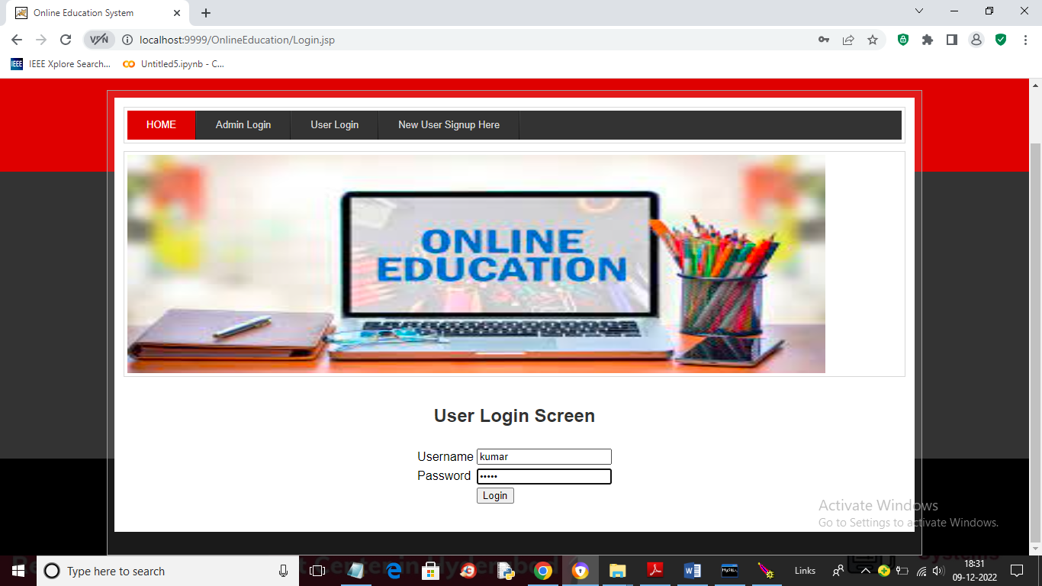 Fig 12: User Login: Post-Login View

In above Fig 12: User is login and after login will get below page.

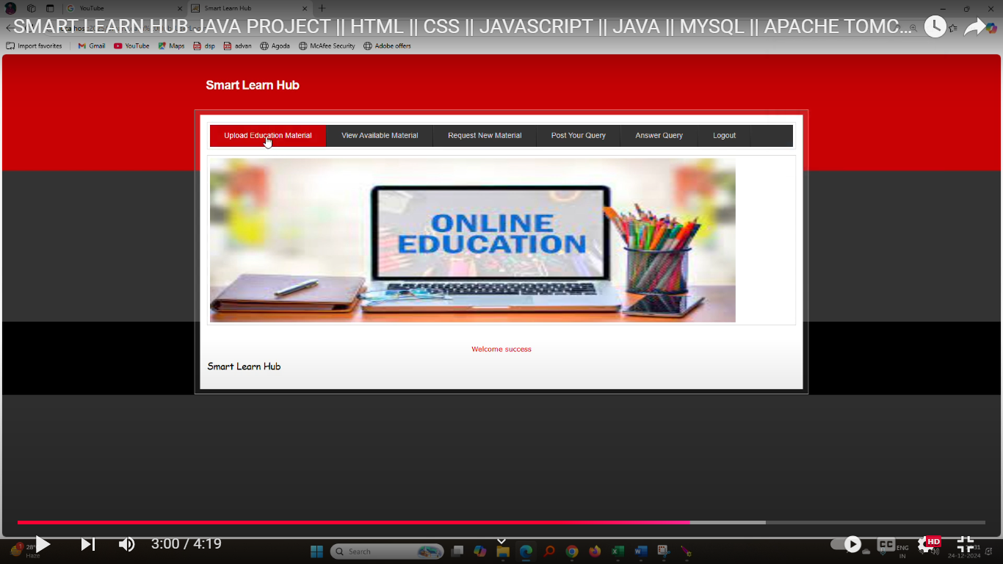Fig 13: Upload Education Material: Link to Upload

In Fig: 13, the user can click on the ‘Upload Education Material’ link to upload the desired material.

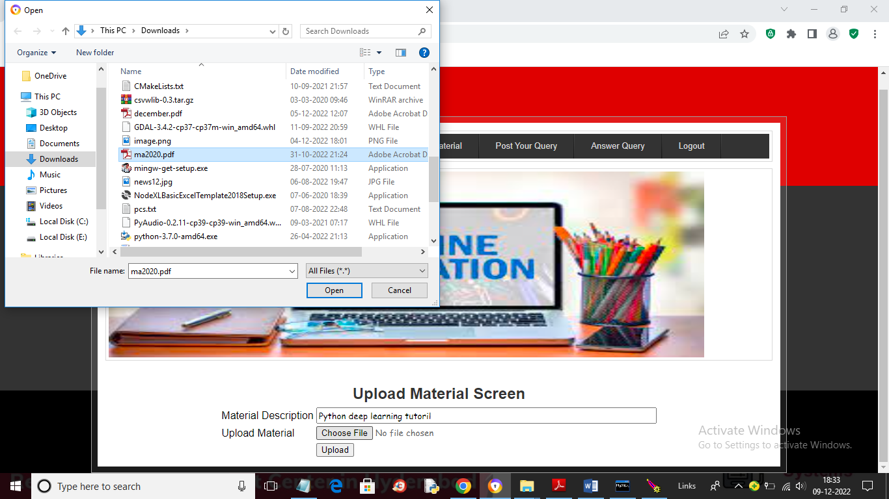

Fig 14: Upload Material: Enter Description and File

In Fig: 14, the user can enter the material description, upload the material file, and then click on the ‘Upload’ button to upload the material and view the output shown below.

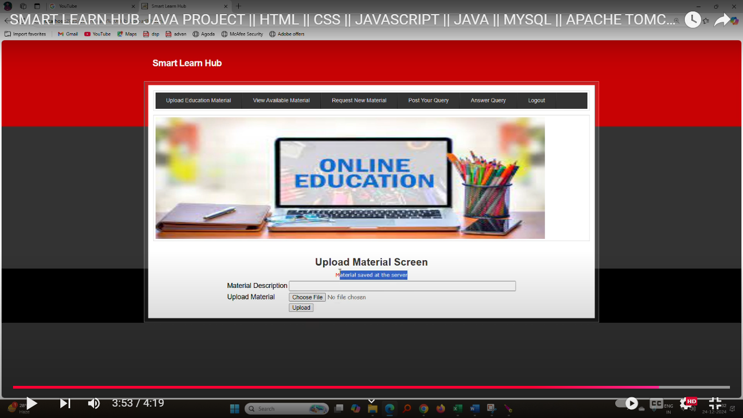Fig 15: Material Uploaded: View Available Material

In Fig: 15, we can see the material has been uploaded. Now, click on the ‘View Available Material’ link to navigate to the screen shown below.

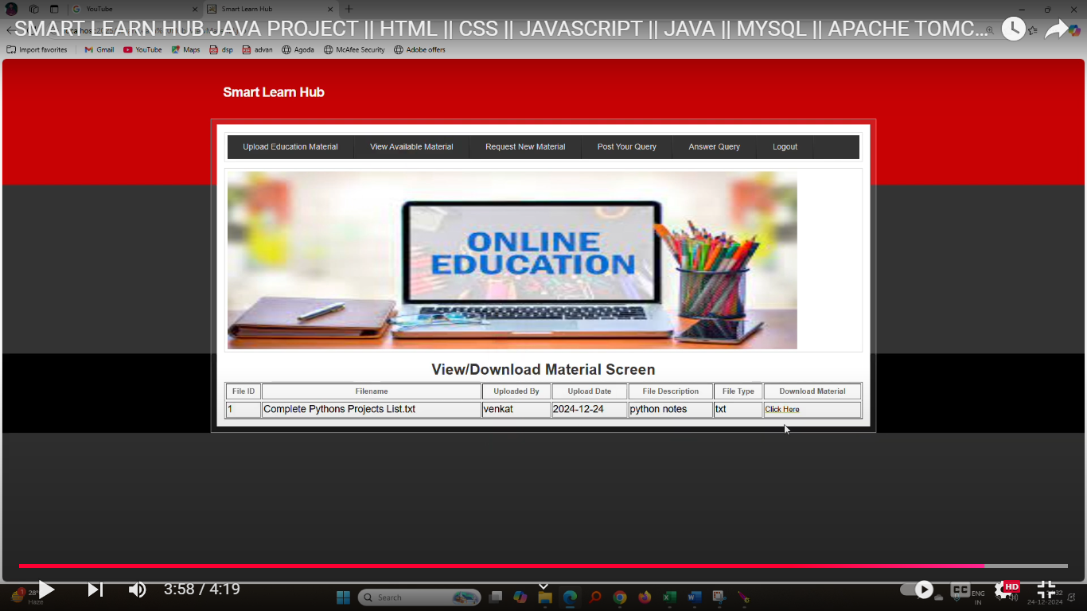Fig 16: Available Tutorials List: Download Option

In above Fig. 16, the user can view the list of available tutorials. If a specific tutorial is needed, they can click on the ‘Click Here’ link to download the material and proceed to next page.

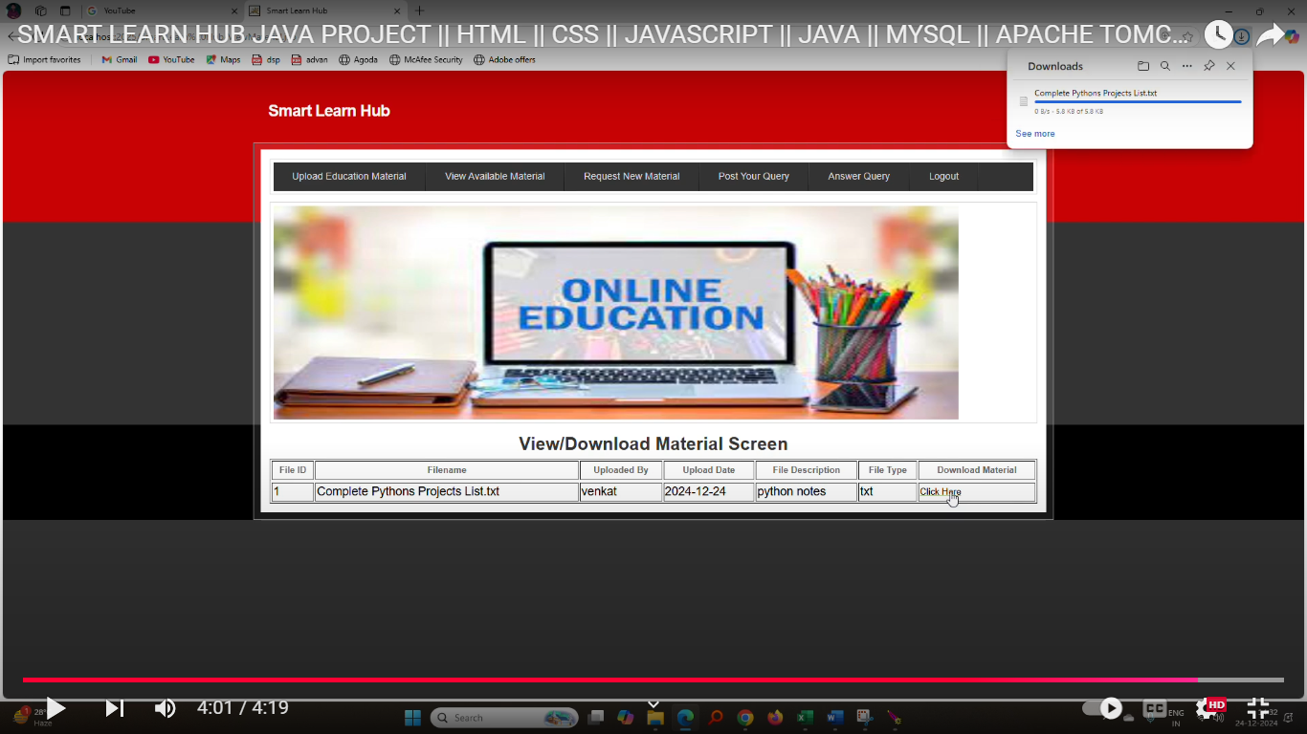Fig 17: Tutorial Download Complete: Request New Material

In the above Fig: 17, the browser status bar shows the tutorial has been downloaded. Now, click on the ‘Request New Material’ link to request a new tutorial.

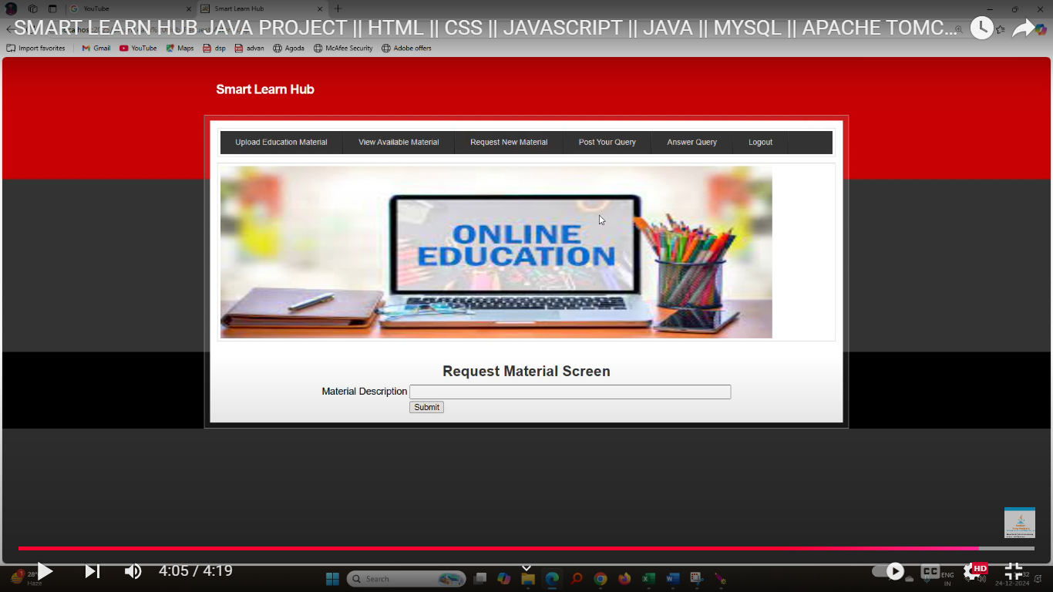Fig 18: User Request for Material

In above Fig: 18, the user can write a description of the material they need and then press the button to send the request to all users. Users who have the requested material will upload it.

In above Fig: 18, the user can now click on the ‘Post Your Query’ link to submit their doubts.

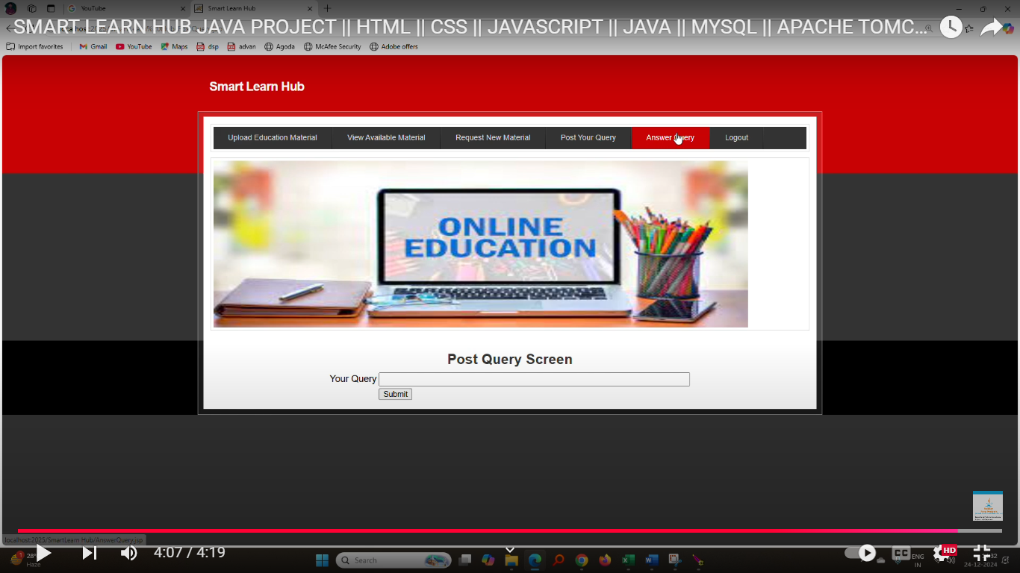Fig 19: User Login to Answer Query

In above Fig: 19, the user can post a query, then log out and log in as another user to answer that query. After logging in, click on the ‘Answer Query’ link to see the output shown below.

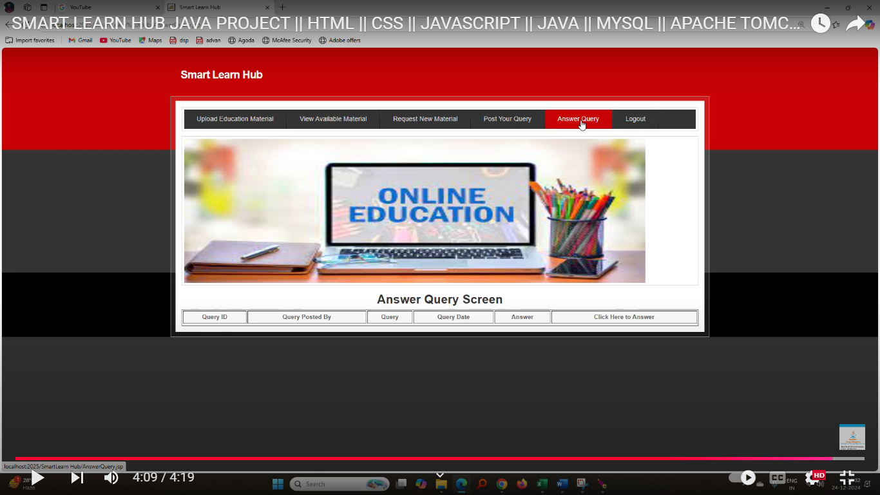

Fig 20: Query Response Options: 'Already Replied' or 'Click Here to Answer

In above Fig: 20, if the query has already been replied to, the option ‘Already Replied’ will be displayed. If the query has not been answered yet, the option ‘Click Here to Answer’ will appear, leading to the page shown below.

Fig 21: User Reply to Query

In above Fig: 21, the user is replying to a query. After submitting the answer, the output shown below will be displayed.

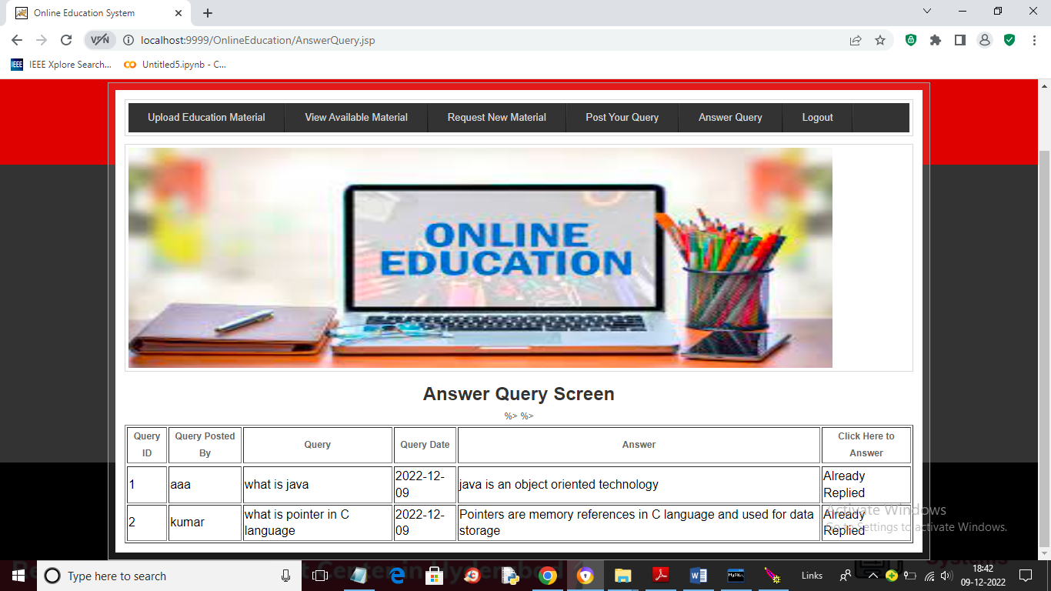

Fig 22: User Query and Answer Display

In above Fig: 22, we can see the given answer is displayed under ‘Answer’ column, visible to all other users, allowing them to view and learn from each query. Similarly, users will use this application to exchange knowledge or education online. Now, log out and log in as the admin.

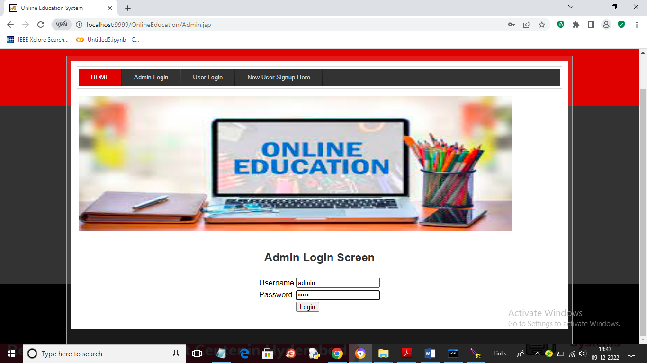

Fig 23: Admin Dashboard: Post-Login View

In above Fig: 23, the admin is logged in. After logging in, the admin will see the page shown below.

Fig 24: Admin: View Registered Users Link

In above Fig: 24, the admin can click on the ‘View Users’ link to see the list of registered users.

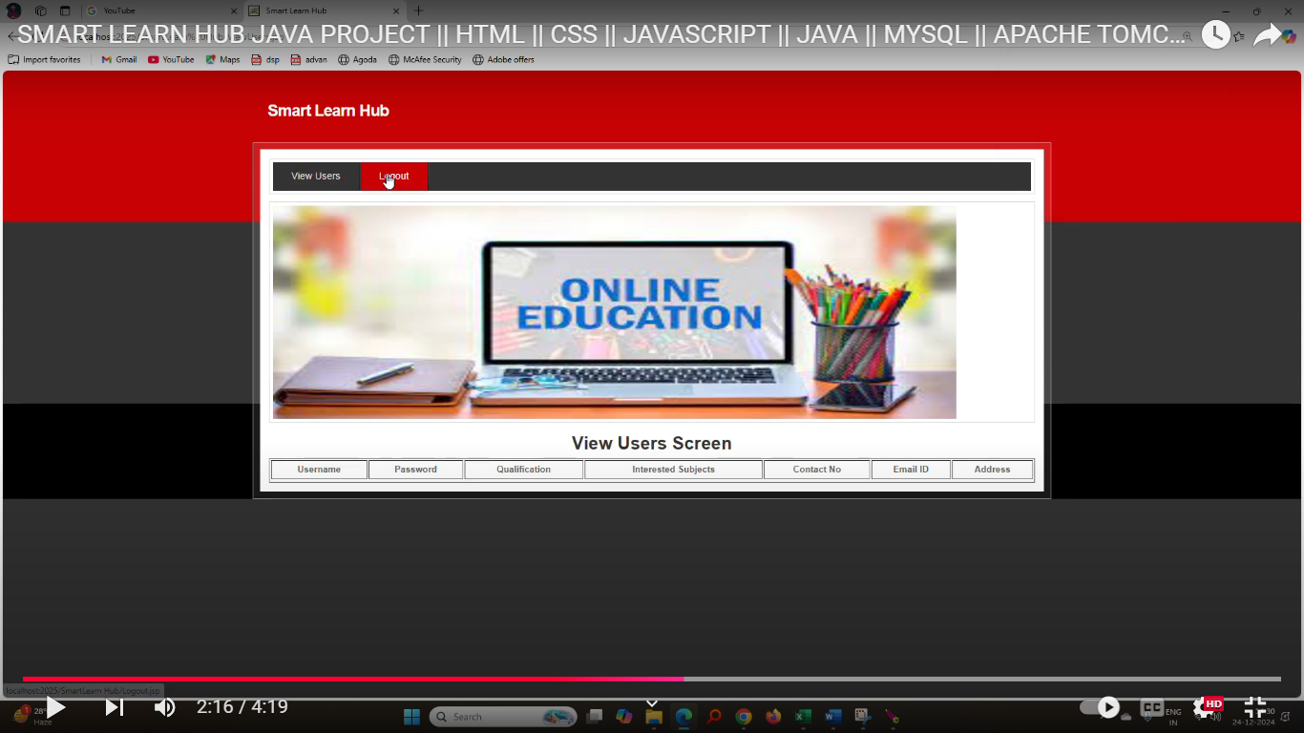Fig 25: Admin View: Registered Users List

In the above Fig: 25, the admin can view the list of registered users.

### **CHAPTER 11**

**FUTURE WORK**

1. **AI-Driven Personalized Learning**

Integrate advanced AI algorithms to analyze user learning patterns and provide personalized content recommendations. This feature will enable the system to adapt to each user's pace, strengths, and weaknesses, ensuring a tailored learning experience. Additionally, predictive analytics can help forecast areas where users might struggle and proactively provide support.

1. **Gamification Enhancements**

Introduce an engaging gamification system to increase user motivation and retention. Features like leaderboards, badges, and level-based progress tracking can foster a sense of achievement. Multiplayer challenges and community-driven quizzes could further enhance interaction and competition among learners.

1. **Offline Access and Synchronization**

Develop an offline mode allowing users to access course materials without an active internet connection. This feature will synchronize user progress and updates once the connection is restored, ensuring uninterrupted learning in areas with limited connectivity.

1. **Multilingual Support**

Expand the platform's reach by incorporating multilingual support. Implementing language localization and translation features will cater to a diverse user base. This addition will make the platform more inclusive, especially in regions with linguistic diversity.

1. **Advanced Performance Analytics for Educators**

Provide educators with a comprehensive analytics dashboard that offers insights into student performance. Real-time data visualization, trend analysis, and predictive tools can help educators identify struggling learners and tailor their teaching strategies for better outcomes.

### **CHAPTER 12**

**CONCLUSION**

The Smart Learn Hub Java application demonstrates the potential of integrating advanced technologies into education to create an intuitive, interactive, and effective learning environment. By leveraging Java's robust capabilities, the application provides a platform that accommodates a variety of educational resources and tools, enabling learners and educators to connect seamlessly. The application ensures accessibility, efficiency, and reliability, making it a valuable addition to modern educational practices. One of the key strengths of the Smart Learn Hub lies in its adaptability to different learning styles and levels. It offers personalized learning experiences, interactive modules, and real-time feedback mechanisms, ensuring that learners remain engaged and motivated. Additionally, the application's modular architecture allows for easy updates and integration of new features, making it future-proof and scalable as educational needs evolve. The application prioritizes user experience through a user-friendly interface, efficient data management, and secure authentication protocols. This ensures a safe and streamlined environment for users, fostering trust and long-term engagement. The inclusion of analytics and progress tracking also empowers educators and learners to monitor performance and make data-driven decisions. In conclusion, the Smart Learn Hub Java application represents a significant step forward in digital education. By combining technological innovation with educational principles, it bridges the gap between traditional and modern learning methodologies. Its impact is not only in enhancing knowledge acquisition but also in shaping a smarter, more inclusive, and efficient learning ecosystem for the future.

### **CHAPTER 13**

**REFERENCES**

1. Rejeb, A., Rejeb, K., Appolloni, A., Treiblmaier, H., &Iranmanesh, M. (2024). Exploring the impact of ChatGPT on education: A web mining and machine learning approach. The International Journal of Management Education, 22(1), 100932.
2. Soliman, M., & Al Balushi, M. K. (2023). Unveiling destination evangelism through generative AI tools. ROBONOMICS: The Journal of the Automated Economy, 4(54), 1.
3. Rane, N., Choudhary, S., & Rane, J. (2023). Education 4.0 and 5.0: Integrating Artificial Intelligence (AI) for personalized and adaptive learning. Available at SSRN 4638365.
4. Maghsudi, S., Lan, A., Xu, J., & van Der Schaar, M. (2021). Personalized education in the artificial intelligence era: what to expect next. IEEE Signal Processing Magazine, 38(3), 37-50.
5. Doshi, P., & Giedd, J. N. (2022). \"Adaptive Learning Systems: The Present and Future of Personalized Education.\" Trends in Cognitive Sciences, 21(12), 938–949. Walls, C. Spring in Action: Practical guide to developing Java applications using the Spring Framework. Publisher.
6. Martin, R. C. Clean Code: A Handbook of Agile Software Craftsmanship. Publisher.
7. Oracle Corporation. Oracle Java Documentation. Retrieved from [Oracle website URL].
8. Paraschiv, E. Building RESTful Web Services with Spring Boot: Tutorials on creating REST APIs using Java and Spring. Baeldung.
9. Wang, L., & Ju, C. Design and Implementation of E-Learning Systems Based on Java. Publisher.
10. Mathkour, H., & Qureshi, R. A Smart Learning Environment Based on Cloud Computing: Research on cloud-based smart learning applications. Journal/Conference Name, Volume (Issue), Page numbers.
11. Raschka, S., &Mirjalili, V. (2019). Python machine learning: Machine learning and deep learning with Python, scikit-learn, and TensorFlow 2. Packt Publishing Ltd.